

Facilitator Guide

1. How to log in 2

2. How to access the MOOCs 4

3. Course Navigation 7

4. Checking your progress through the course 8

5. Checking Class Progress 10

6. Using discussion forums 15

7. Knowledge checks 18

8. Viewing the MOOC as a participant​ 20

# How to log in

* Login using your user name and password on NALA’s login portal: <https://learn.nala.ie/>
* You will be sent with this information through email.

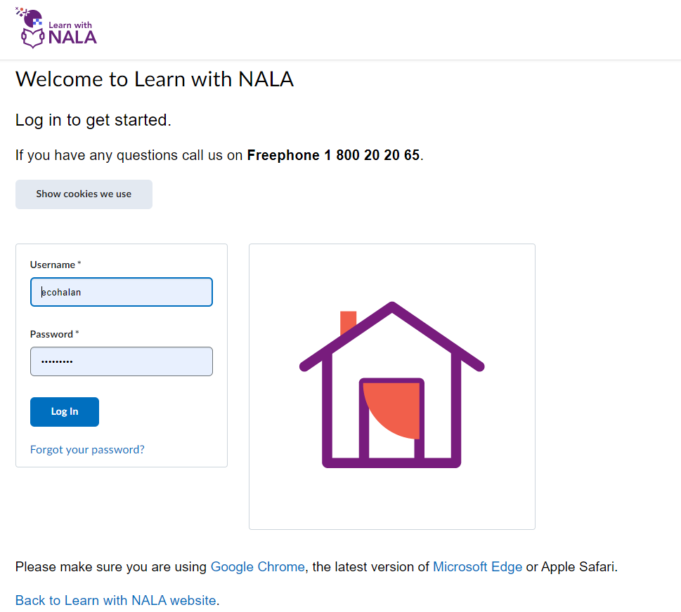

You are registered as an **‘Instructor’.**Your main dashboard will look like this.

This is the standard dashboard for Learn with NALA that is used for all our programmes. Please be aware that not all content on this page will be relevant to you or the participants on the pilot MOOCs.

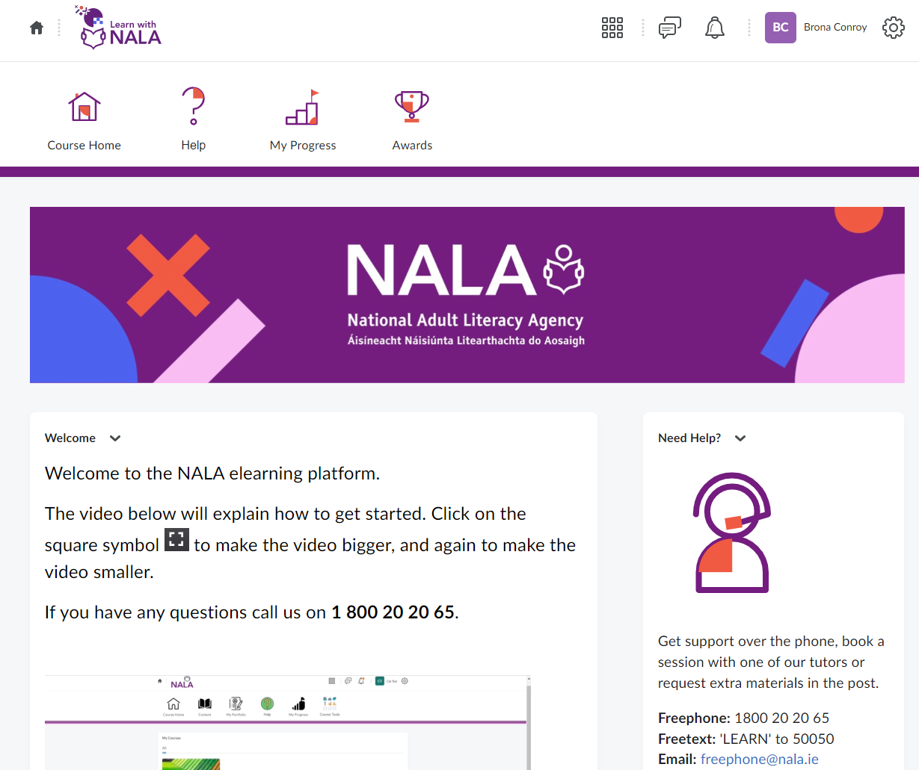

# 2. How to access the MOOCs

* Scroll down on your home screen to find the courses. Click on the course you wish to access.

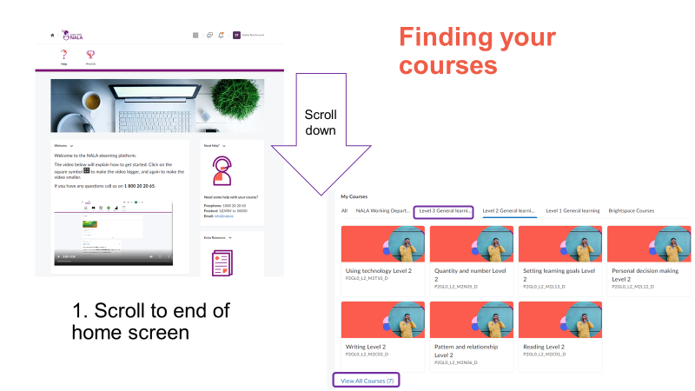

* This will take you to the course home page.
* To access the course content simply click ‘Content’ on the navigation menu.

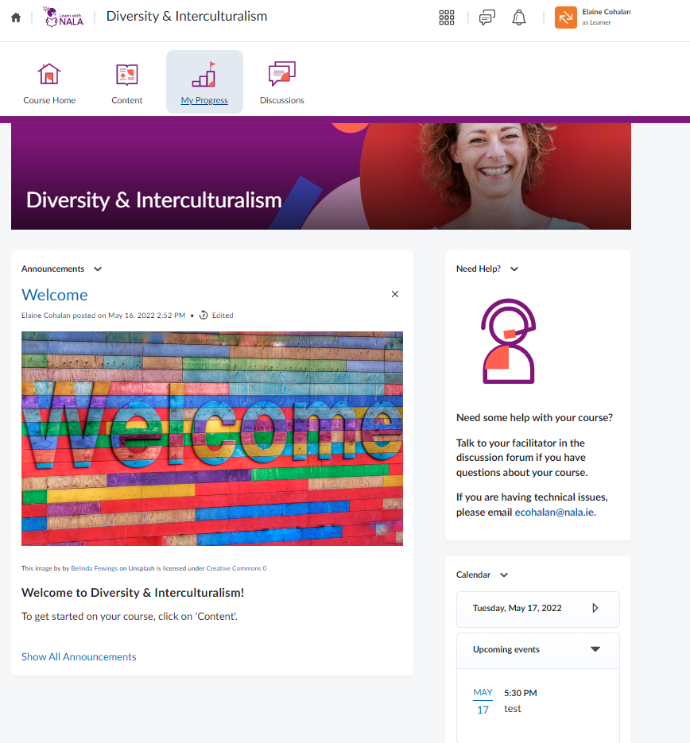

* Once you have selected content, you will see the below screen which is a table of contents linking to the course content.
* To get started, simply click ‘Get Started’. This will take you to the content screen.

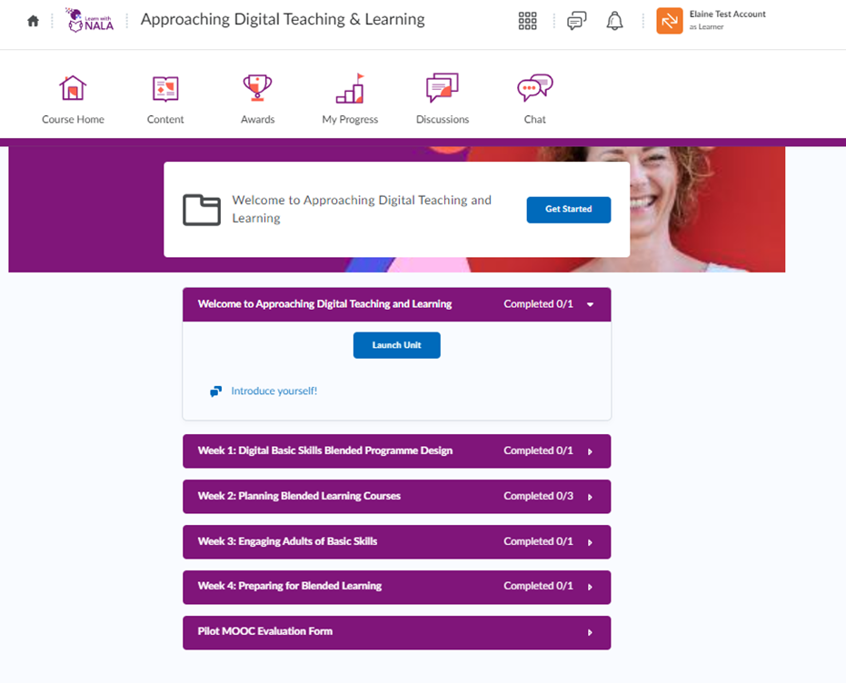

# Course Navigation

* You can use the arrows on the top right of the screen to navigate back and forth between screens.
* You can use the scroll bar on the right hand side to scroll through the content on this screen.
* At any time you can navigate back to the table of contents page by clicking ‘Back to Content’ on the top left of the screen.

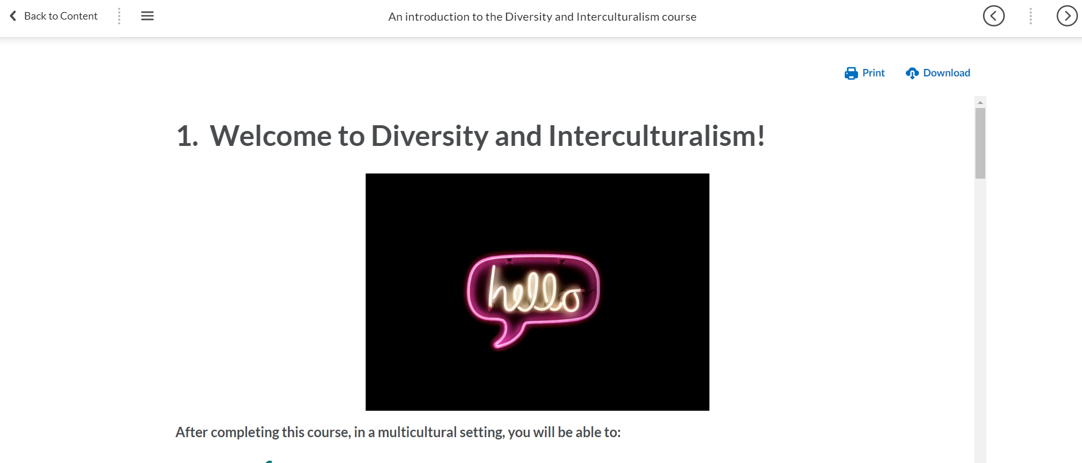

# 4. Checking your progress through the course

* You can view where you are in the unit by clicking the  icon with three horizontal lines on the top left of the screen.

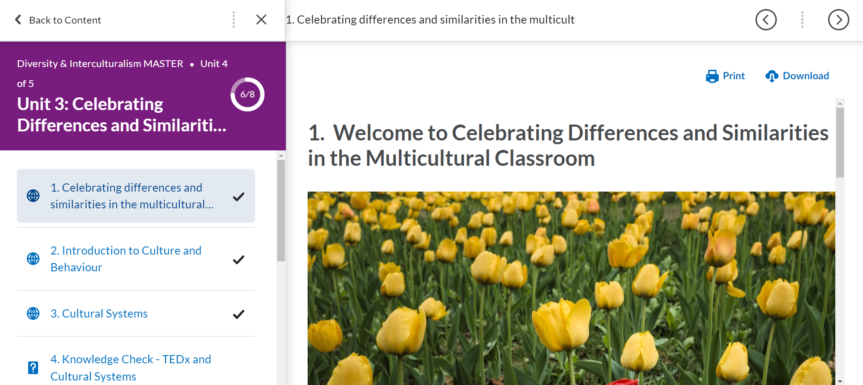

* When you navigate out of the content, the table of content page will remind you where you finished and you pick up where you left off by clicking ‘Continue’.

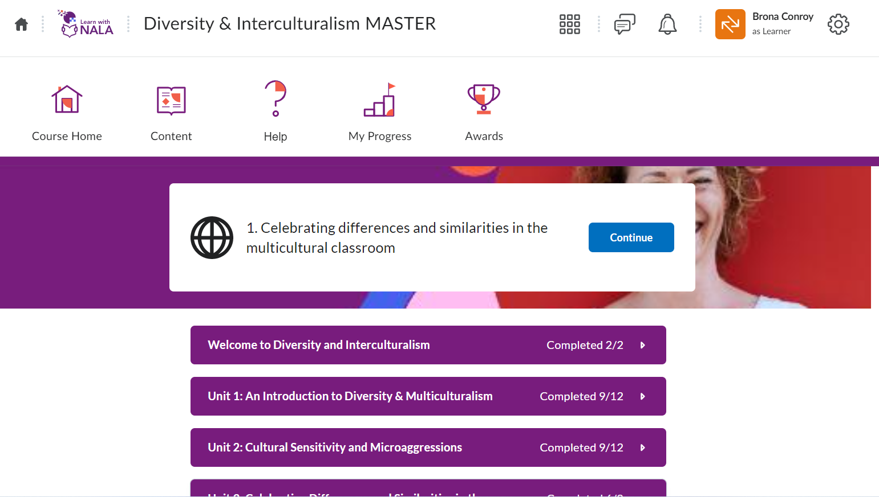

# 5. Checking Class Progress

* You can check how participants are progressing with the course by clicking on ‘Class Progress’.

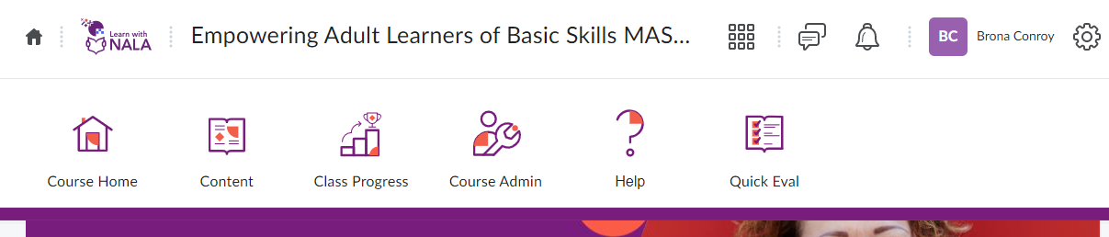

* You can see how much of the course they have completed under ‘Content Visited’. Participants must visit 100% of the course content to get their certificate.

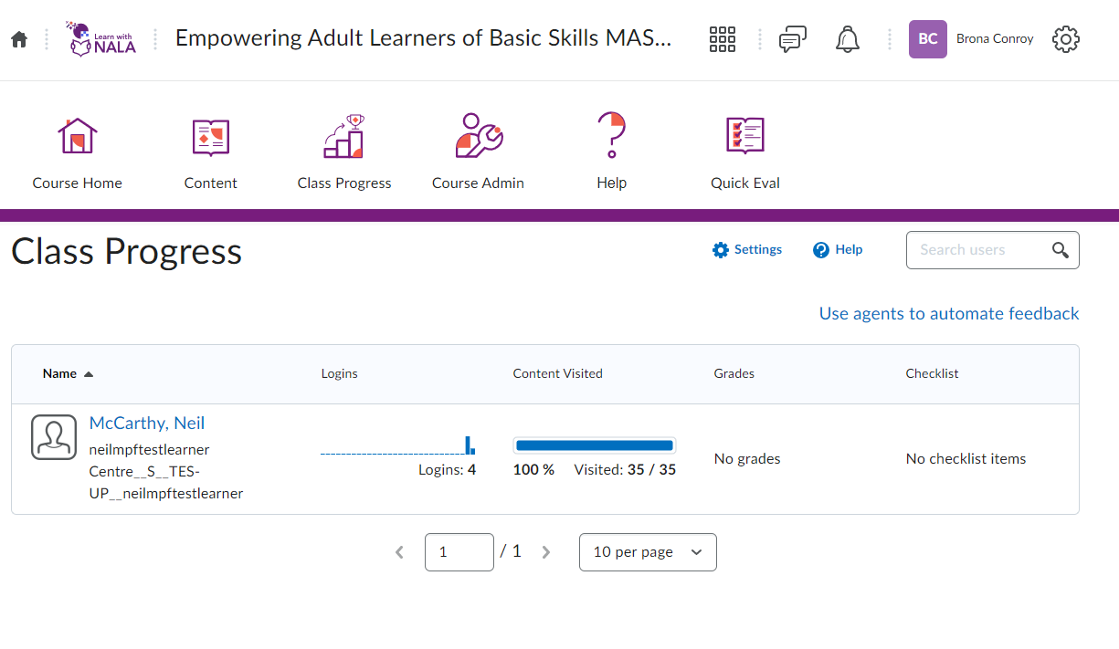

6. Using announcements​

* To create an announcement, click on ‘Course Admin’ and ‘Announcements’.

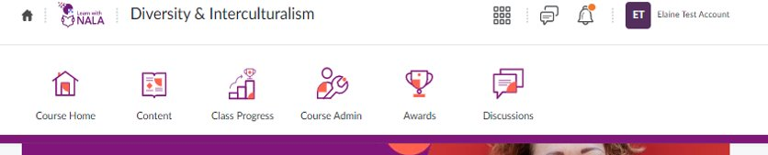

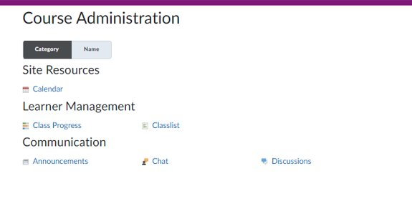

* This will show you all current and previous announcements on the course.
* To create a new announcement, click ‘New Announcement’ and enter the headline and text. You can add images, links etc. in the content section. ​

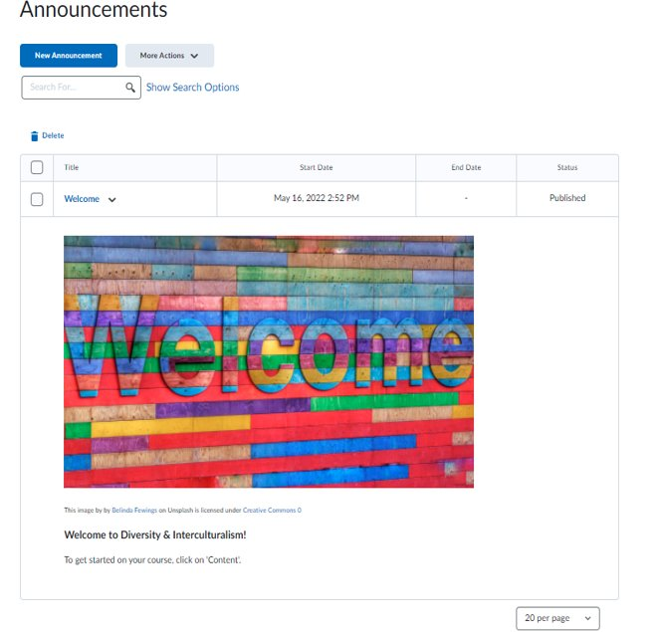

* If you want the announcement to only appear in certain conditions, such as between specific dates, you can edit the start and end date. ​
* Once you are finished, click ‘Publish’. ​

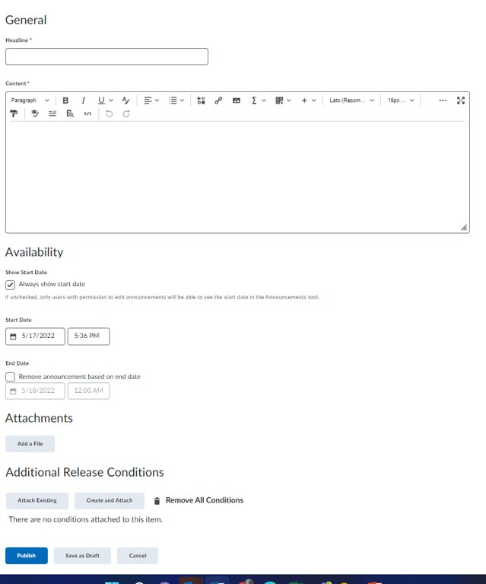

* The participants on the course will see the announcement when they log in next.

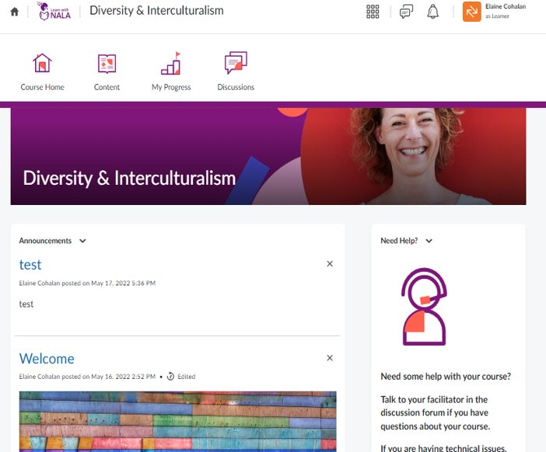

# 6. Using discussion forums

There are a number of discussion forums in each course. As a facilitator, you can add the topics you wish here.

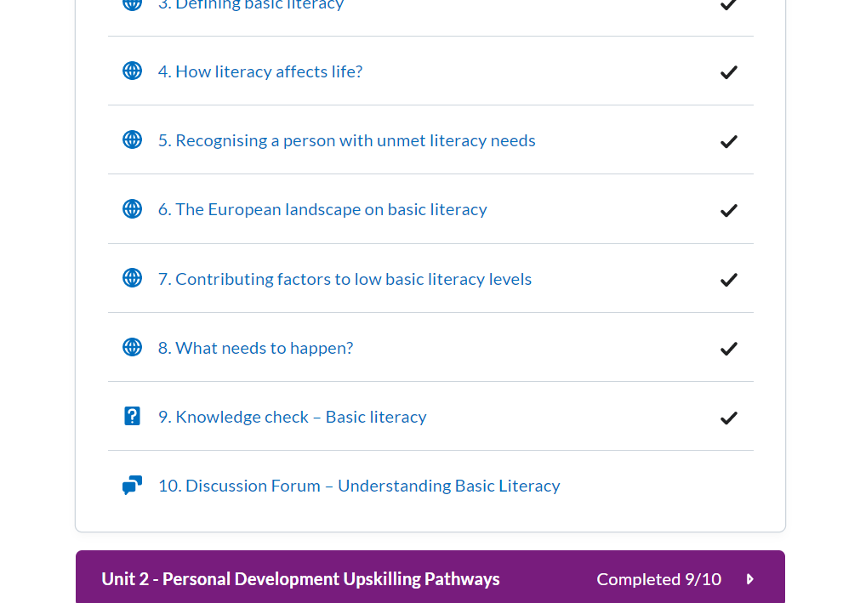

Click on the Discussion topic and **‘Start a new thread’** to post a comment.

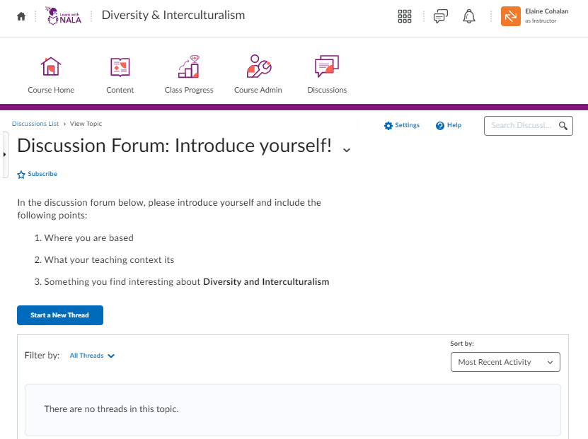

Click **‘Post’** for the thread to appear on the screen.

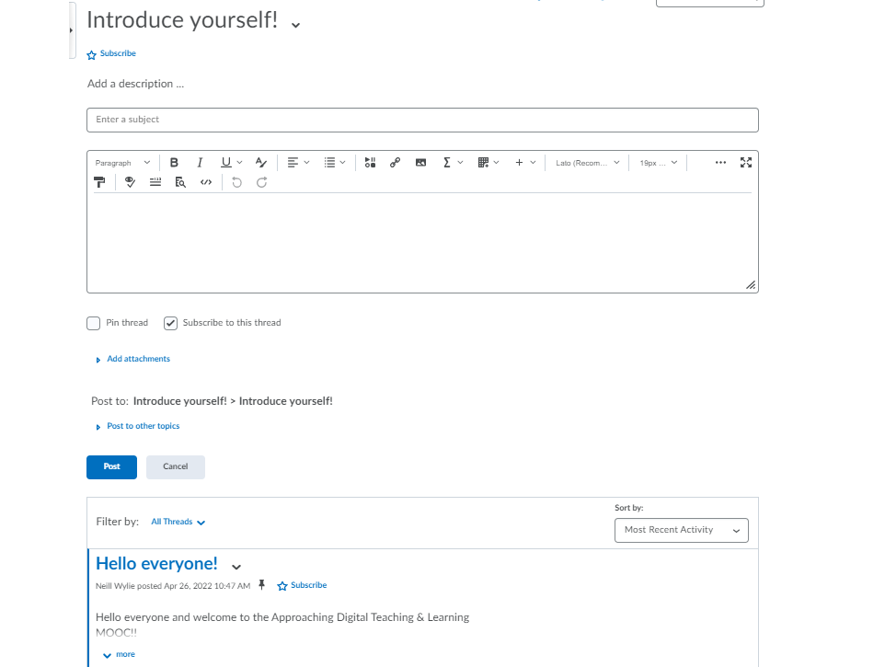

# 7. Knowledge checks

* Each course has knowledge checks which are ways a learner can self-assess their progress in a course.



* To access a self-assessment in a unit, click **‘Go to quiz’.**
* Learners will get their results immediately.

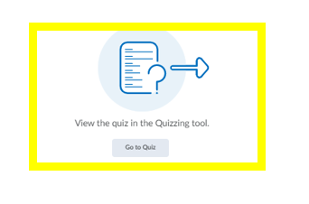

# 8. Viewing the MOOC as a participant​

* To view the course as a learner, go to your name bar and left-click to view the dropdown.

